

Preboard Examination - 2080
Subject: Digital Logic FM: 80
Semester: B.Sc.CSIT 1st Semester Time: 3 hrs
Candidates are required to give their answers in their own words as for as practicable. The figures in the margin indicate full marks.
Long Questions:
Attempt any two questions: (2 X 10 = 20)
1. What are the major differences between Programmable Array Logic (PAL) and ROM? Implement the following two Boolean functions with a Programmable Logic Array (PLA):
F(A, B, C) = Σ (0, 1, 3, 4)
G(A, B, C) = Σ (0, 3, 6, 7)
2. Design a sequential circuit that follows the given state diagram using JK Flip Flops.
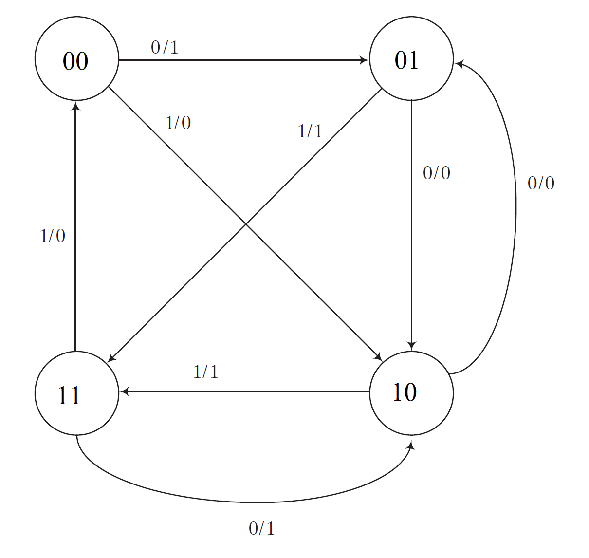
3. What is Ripple Counter? Explain the working of a 4-bit universal shift register, which can shift left, shift right and load 4 bit data parallelly based on the selection code.

Short Questions:
Attempt any eight questions: (8 X 5 = 40)
4. What is 2’s complement? Subtract (1001.10)₂ from (1010.01)₂ using 2’s complement method.
5. Find the complements of the following functions:
a. F₁ = a’b’c + abc’ + bc
b. F₂ = (x + y’ + z’)(x y’ z + y z’)
6. What is a ring counter? Draw the circuit diagram of 3 bit binary ripple counter using D flipflop.
7. Design a 5×32 decoder with four 3×8 decoders with enable and one 2×4 decoder. (Use block diagram only.)
8. Explain the Binary Cell of RAM and its working along with circuit diagram.

9. Implement the following function using 4X1 Multiplexer. Draw the corresponding circuit diagram.
F (A, B, C) = Σ(0, 3, 6, 7)
10. Write down the Characteristic Equations, Characteristic Tables and Excitation Tables of the D Flip-Flop, T Flip-Flop and JK Flip-Flop.
11. Explain the equivalent states with examples. Why is an analysis of equivalent states important in the design of the synchronous sequential circuits?
12. Draw the circuit diagram for the Three Stage (Mod-6) Johnson’s counter. Mention the Count Sequence for the counter and the corresponding decoding AND terms.
13. Write Short notes on (any two):
a) Parity Generator and Checker Circuit for Even Parity System
b) JK Flip-Flop
c) Priority Encoder

